Cognizant Digital Nurture (DN) Program – Deep Skilling
Track : Java Full Stack Engineering (FSE)
Hands-on Exercises week 1
Data Structures and Algorithms
Submitted by : Kanala Nikitha

Exercise 2: E-commerce Platform Search Function
Product.java
public class Product {
int productId;
String productName;
String category;
public Product(int productId, String productName, String category) {
this.productId = productId;
this.productName = productName;
this.category = category;
}
@Override
public String toString() {
return "ID: " + productId +
", Name: " + productName +
", Category: " + category;
}
}
SearchDemo.java
import java.util.Arrays;
import java.util.Comparator;
public class SearchDemo {
// Linear Search
public static Product linearSearch(Product[] products, String name) {
for (Product product : products) {
if (product.productName.equalsIgnoreCase(name)) {
return product;
}
}
return null;
}

// Binary Search
public static Product binarySearch(Product[] products, String name) {

int left = 0;
int right = products.length - 1;

while (left <= right) {
int mid = (left + right) / 2;

int compare =
products[mid].productName.compareToIgnoreCase(name);

if (compare == 0) {
return products[mid];
} else if (compare < 0) {
left = mid + 1;
} else {
right = mid - 1;
}

return null;
}
public static void main(String[] args) {
Product[] products = {
new Product(101, "Laptop", "Electronics"),
new Product(102, "Phone", "Electronics"),
new Product(103, "Shoes", "Fashion"),
new Product(104, "Watch", "Accessories"),
new Product(105, "Tablet", "Electronics")
};
String searchItem = "Watch";
System.out.println("=== Linear Search ===");
Product result1 = linearSearch(products, searchItem);
if (result1 != null)
System.out.println(result1);
else
System.out.println("Product Not Found");
Arrays.sort(products,
Comparator.comparing(p -> p.productName));
System.out.println("\n=== Binary Search ===");
Product result2 = binarySearch(products, searchItem);
if (result2 != null)
System.out.println(result2);
else
System.out.println("Product Not Found");}}
Output:
=== Linear Search ===
ID: 104, Name: Watch, Category: Accessories
=== Binary Search ===
ID: 104, Name: Watch, Category: Accessories

Analysis:
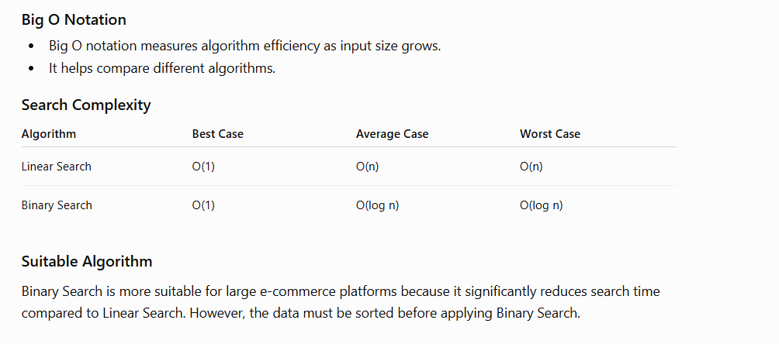

Exercise 7: Financial Forecasting

FinancialForecast.java

public class FinancialForecast {
// Recursive method
public static double futureValue(double currentValue,
double growthRate,
int years) {
if (years == 0) {
return currentValue;
}
return futureValue(currentValue,
growthRate,
years - 1) * (1 + growthRate);
}
public static void main(String[] args) {
double currentValue = 10000;
double growthRate = 0.10; // 10%
int years = 5;
double predictedValue =
futureValue(currentValue, growthRate, years);
System.out.printf(
"Predicted Future Value after %d years = %.2f",
years,
predictedValue);
}
}
Output:
Predicted Future Value after 5 years = 16105.10
Analysis:
Recursion:
Recursion is a technique where a method calls itself to solve smaller instances of the same problem.
Time Complexity:
Recursive Calls = n
Time Complexity = O(n)
Optimization:
To avoid excessive computation:
Use Dynamic Programming (Memoization).
Use Iterative Approach instead of recursion.
Store previously computed values.
Why Recursion?
Recursion makes the forecasting logic simple and easy to understand, especially when calculations depend on previous years' values.

